Gaggo’s Website

@GaggosFamily | Twitter

Made for commissions and other shenanigans

Gaggo smies

2022

# Table of Contents

Table of Contents 1

1 Premise 2

2 Front End 3

2.1 Commissions 3

2.2 Queue 4

2.3 Accept, reject and finish commissions (Admin) 4

3 Backend 5

3.1 Data structure 5

3.2 Pending 5

3.3 Accepted (queue) 5

3.4 Done 5

3.5 Rejected 5

4 Services 6

4.1 Source Control (Github) 6

4.2 Website Hosting (Netlify) 6

5 References 7

|  |  |  |
| --- | --- | --- |
| Revision version | Date | Description |
| 0.1 | 9.4.2022 | Created document |
| 0.2 | 9.4.2022 | Changed the data structure and API |

# Premise

The idea behind the website is to have a hub for GaggosFamily. The first phase is to make the website so potential customers can order from Gaggo, but eventually the website will have different features, such as showing all socials to Gaggo and to have similar asking platform as CuriousCat (CuriousCat, 2022).

# Front End

Frontend consists is themed around Gaggo’s fursona, Gaggo. Gaggo is a feral feline who resembles Gaggo’s online persona. The website shall be cozy and comfortable to use.

## Commissions

Commissions screen will present the user with defined aspects of the ordered commission (such as if the image quality and quantity of characters), then the final price is shown to the user, asking them to confirm the order. Once the order is confirmed, the website will send the order in a specific Data structure to Pending worksheet tab.

The different aspects will be shown with a CSS hover animation, with buttons “Next” and “Back”. Button “next” is colored differently than anything else, so it stands out more. Before the final step, the “Next” button changes to “Finish”, and once “Finish” button is pressed, the website makes a new screen pop out, asking the user to confirm the order. The final step shall show the summary of the order and the expected price.

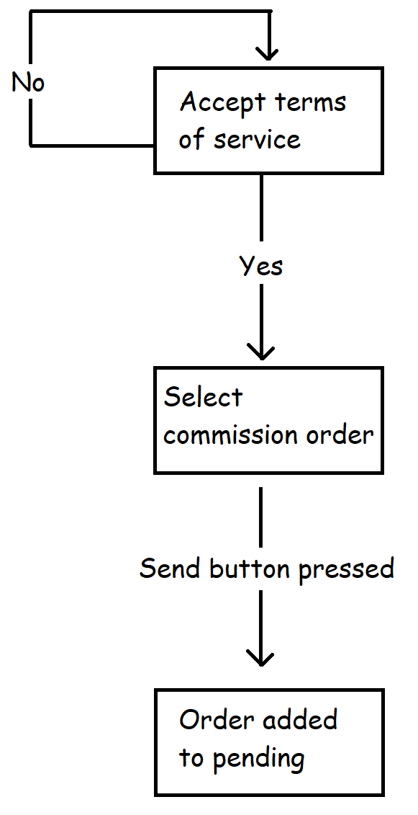Before the user can start the commission process, they have to read and accept the terms of service.

Figure 1: Commission process

## Queue

Queue will show read-only data from Accepted (queue) worksheet. Here the customer can see the username of the customer and some other details, like the quality and quantity of the image.

## Accept, reject and finish commissions (Admin)

This page is only locally run on Gaggo’s PC. It will show different pending and accepted commissions, similar to Queue, expect there will be buttons to accept or reject pending requests.

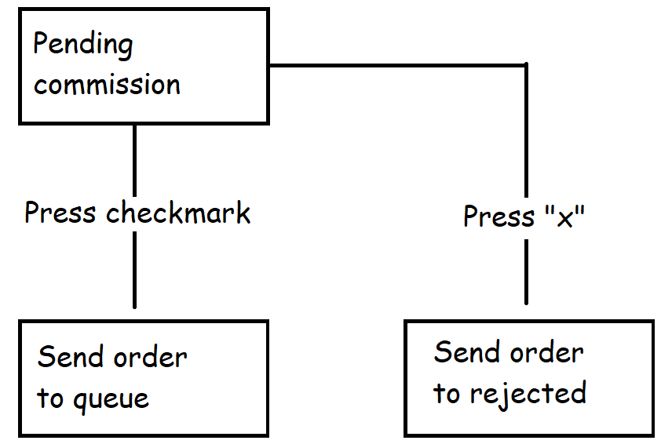

Figure 2: Accept or reject commission process

# Backend

For the backend, Google Excel will be used (Google, 2022). The sheet will have 4 stautuses: Pending, Accepted, Done and Rejected. The API used will be from SheetDB (SheetDB, 2022).

## Data structure

The data structure is defined in Table 1.

Table 1: Data structure

|  |  |
| --- | --- |
| Name | Description |
| ID | Maybe set by Excel sheet itself? |
| Username | Commission customer. Maybe add prefix of where to contact the customer? |
| Quality | Art quality: flat color, shaded, shaded and highlighted; emojis, comics? |
| Character quantity | How many characters? |
| Background | What kind of background? |
| Price | Expected price (Subject to change after the order). |
| Date | Date when commission request was made. |
| Status | Status if commission is: pending, accepted, done or rejected. |

## Pending

Pending worksheet tab is only visible for Gaggo. The backend could be shown in a front-end website ran locally on Gaggo’s machine, where he can either accept the commission and add it to the queue, or reject the commission.

## Accepted (queue)

Once the order has been accepted, the customer is added to the queue. The queue will be public as to show the expected wait time for the customer. A website and API calls will be made for this sheet to show the orders better.

## Done

Once the accepted commission is done, it can be set to done. The only purpose here is to have logs of finished commissions.

## Rejected

If the commission is rejected, the status is set rejected. The purpose of this is to have logs of potentially unwanted customers, or to get data from rejected commission to accepted commission.

# Services

## Source Control (Github)

The source control will be saved in: <https://github.com/Gaggosmies/GaggoWebsite>.

## Website Hosting (Netlify)

The website will be hosted from Netlify. Netlify is a free service to hobby sites (Netlify, 2022), which can host HTML websites from Github repository.

The website can be found from URL: <https://gaggowebsite.netlify.app/>

## API (SheetDB)

The API used will be SheetDB, which is free API service to Google Sheets. The free service consists of 500 requests per month (SheetDB, 2022).

The website can be found from URL: <https://sheetdb.io/>

# References

CuriousCat. (2022). *About*. Retrieved from Curiouscat: https://curiouscat.live/about

Google. (2022). *Google Sheets API*. Retrieved from Google developers: https://developers.google.com/sheets/api

Netlify. (2022). *Netlify Pricing*. Retrieved from Netlify.com: https://www.netlify.com/pricing/